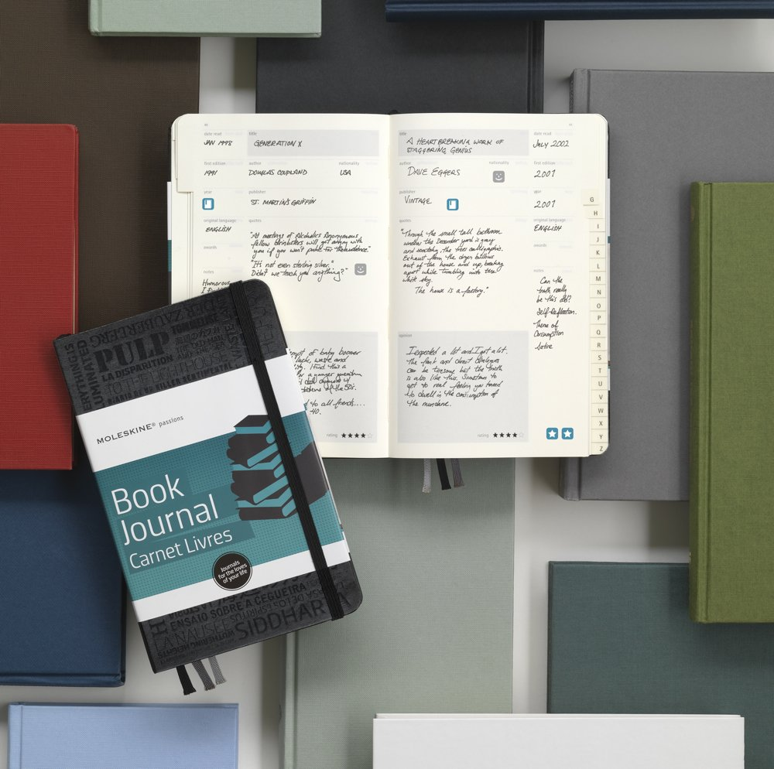

✹

“A blank page always inspires a visit to the bathroom, hunger, thirst, caffeine addiction, a demand for more research, consultation with a colleague,”(Murray 41).

* Choose any meaningful image that is reflective of your experience as a reader and writer.
* Attach a “window” (post-it) to your artifact that explains its meaning and significance.
* Share
* Archive

## the process

✹

Artifacts